Albany College of Pharmacy and Health Sciences presents
SCIENCE, CULTURE AND MEDICINE SEMINAR SERIES
A TALK BY GEORGE SALIBA, Ph.D.
PROFESSOR OF ARABIC AND ISLAMIC SCIENCE AT COLUMBIA UNIVERSITY

The Impact of
Arabic/Islamic Science on
Medicine and Pharmacology
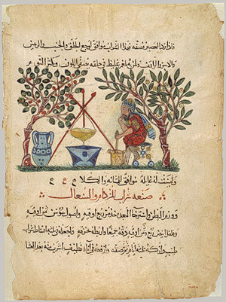

Thursday, April 5 at 7:00 pm
Albany College of Pharmacy and Health Sciences
Student Center, Room 202, 41 Union Drive, Albany, NY
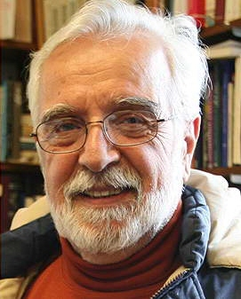
Sponsored by Albany College of Pharmacy and Health Sciences and the Iraqi Refugee Project
While European science slept through the “Dark Ages,” intellectual developments in the Arab/Islamic world transformed scientific thought, creating the foundation for modern empirical science and the scientific method. Dr. Saliba, author of Islamic Science and the Making of the European Renaissance (2007) among other books, will discuss how these developments ultimately led to significant advances in pharmacology and medicine.

